DIVISION BY 2
KS1 – 2001 Paper
1.
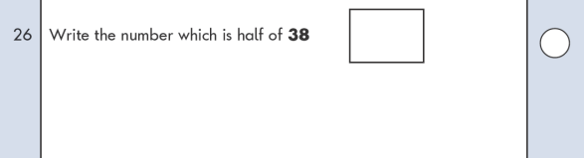
2.
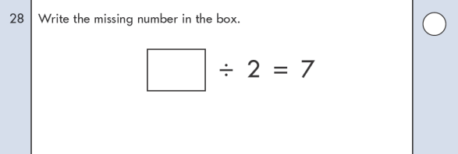
KS1 – 2002 Paper
3.
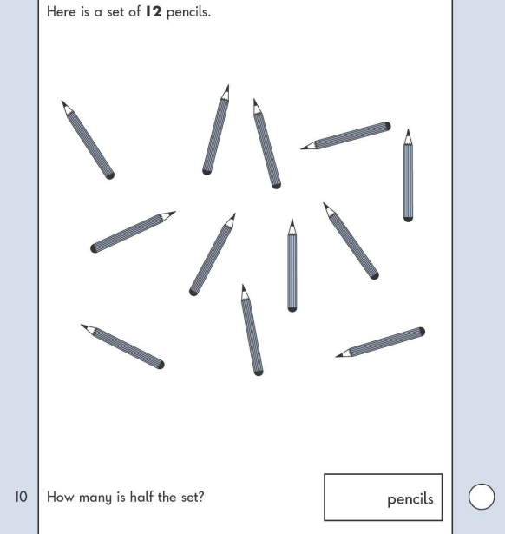
KS1 – 2009 Paper 1
4.
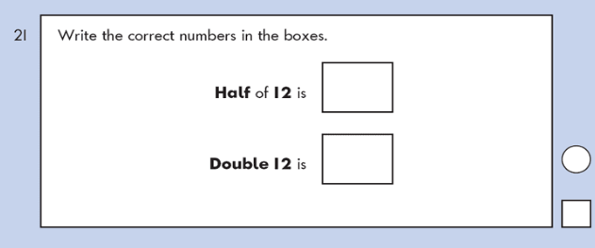
KS1 – 2016 Paper - Arithmetic
5.
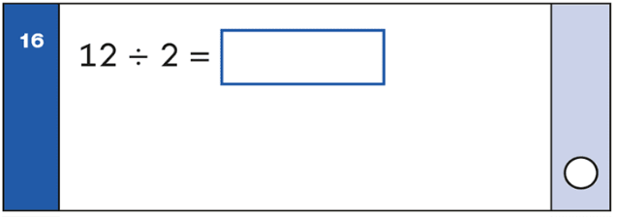
KS1 – 2016 Paper - Arithmetic (Second)
6.

KS1 – 2017 Paper – Arithmetic
7.
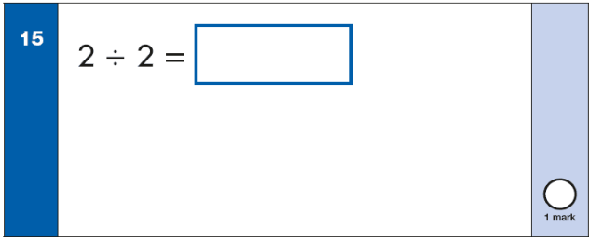
KS1 – 2018 Paper – Arithmetic
8.
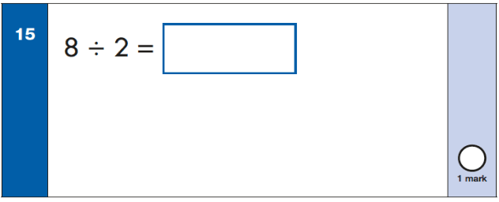
KS1 – 2019 Paper – Arithmetic
9.
